EXCEL: SWIGGY DASHBOARD ANALYSIS

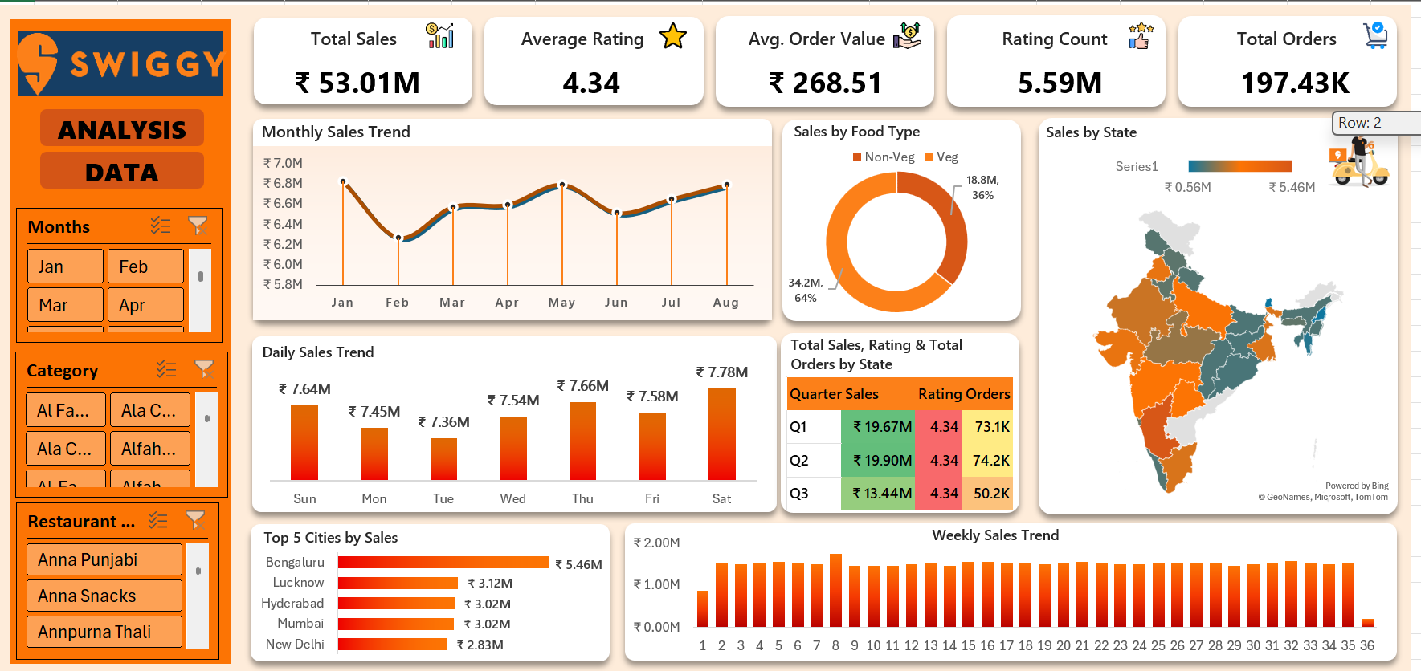

📌 Phase 1: Understanding the Business Requirement (BRD)
The business wants to answer key questions such as:
- How much revenue are we generating?
- Are customers satisfied?
- Which states and cities generate the most business?
- How do sales trend over days, weeks, and months?
- What’s the difference between Veg and Non-Veg performance?
So, I identified five KPIs:
- Total Sales — ₹53.01M
- Average Rating — 4.34
- Average Order Value — ₹268.51
- Ratings Count — 5.59M
- Total Orders — 197K

📌 Phase 2: Designing Charts & Visuals
To present insights effectively, I created:
- Monthly Sales Trend → shows seasonal patterns & monthly consistency
- Daily Trend → identifies which days perform better
- Veg vs Non-Veg Sales Donut Chart → non-Veg appears dominant
- State-wise Map → helps see regional contribution
- Quarterly Summary Table → merges Sales + Orders + Rating for business decisions
- Top 5 Cities by Sales → Bengaluru leads with ₹5.46M
- Weekly Trend → for operational planning & peak week detection

📌 Phase 3: Building the Dashboard
I added interactive slicers:
- Month
- State
- Restaurant
- Food Type
These allow stakeholders to filter data dynamically.
The final dashboard helps operators and management understand:
- When sales peak
- Which regions outperform
- Which cuisine dominates
- How customer satisfaction correlates with orders

✅ PART 2 — INTERVIEW QUESTIONS & STRONG ANSWERS
Below are the exact questions interviewers ask for such a project — along with ideal answers.

🔶 Basic-Level Interview Questions
1️⃣ What was the objective of your project?
Answer:
“The objective was to analyse food delivery performance using KPIs like Total Sales, Order Volume, and Ratings. I created an interactive dashboard to help business stakeholders track revenue trends, customer behavior, and geographical performance.”

2️⃣ What tools did you use?
Answer:
“I used Excel for data cleaning, pivot tables, pivot charts, slicers, conditional formatting, and interactive dashboard creation.”

3️⃣ ✅ DATA CLEANING
3️⃣ Created New Derived Columns (Feature Engineering)
To enhance the analysis and make the dashboard more insightful, I generated several calculated fields:

🔸 a) Quarter Extraction
Formula:
="Q"&INT((MONTH([@[Order Date]])-1)/3)+1
Purpose:
This converts each order date into its respective quarter (Q1–Q4), allowing quarterly performance comparison in the dashboard.

🔸 b) Week Number Extraction
Formula:
=WEEKNUM([@[Order Date]])
Purpose:
Helps analyze weekly sales patterns and identify peak or low-performing weeks.

🔸 c) Food Type Classification (Veg / Non-Veg)
Formula:
=IF(OR(
ISNUMBER(SEARCH("chicken", K3)),
ISNUMBER(SEARCH("egg", K3)),
ISNUMBER(SEARCH("fish", K3)),
ISNUMBER(SEARCH("mutton", K3)),
ISNUMBER(SEARCH("prawn", K3)),
ISNUMBER(SEARCH("biryani", K3)),
ISNUMBER(SEARCH("kabab", K3)),
ISNUMBER(SEARCH("kebab", K3)),
ISNUMBER(SEARCH("Non-Veg", K3)),
ISNUMBER(SEARCH("non veg", K3))
), "Non-Veg", "Veg")
Purpose:
Identifies whether the dish is Veg or Non-Veg based on keywords. This enabled the Veg vs Non-Veg comparison chart in the dashboard.

🔸 d) Additional Derived Columns (Optional to mention)
You can also say:
- Extracted Month Name, Day Name, and Year for trend analysis
- Created Average Order Value, Total Orders, etc.

🔶 Intermediate-Level Interview Questions
4️⃣ Why did you choose these KPIs?
Because they represent:
- Revenue performance: Total Sales, AOV
- Customer satisfaction: Ratings, Rating Count
- Business volume: Total Orders
They provide a 360-degree overview of the business.

5️⃣ What were your key insights?
Examples based on your dashboard:
- Saturday has the highest sales (₹7.8M)
- Non-Veg contributes 37.1% of revenue
- Bengaluru is the top-performing city (₹5.46M)
- Q1 performs slightly better in orders compared to Q3
- Sales fluctuate across months but show a slight upward trend in Aug

6️⃣ Why did you add slicers?
Slicers make the dashboard dynamic, so business teams can quickly analyze:
- Month-wise performance
- State-wise comparison
- Restaurant-wise contribution
This adds flexibility without modifying charts manually.

🔶 Advanced-Level Interview Questions
7️⃣ How does this dashboard help the business?
It enables:
- Operational planning: identify peak days/weeks
- Marketing strategy: focus ads on high-performing states/cities
- Menu planning: promote Non-Veg during high demand
- Customer engagement: improve ratings in low-rated quarters/states

8️⃣ What challenges did you face?
You can say:
- Combining multiple datasets
- Managing large data in Excel without lag
- Making charts clean & easy to interpret
- Aligning visuals to look professional

9️⃣ If you had more time, what would you improve?
Possible improvements:
- Build Power BI version for better visuals
- Add forecasting (future orders/sales)
- Create restaurant-level deep dive
- Add customer demographics if available

🔟 Explain one insight that surprised you.
Example:
“Sales were highest on Saturday, which indicates weekend dining preference. This helps operations allocate more delivery partners during weekends.”
✅ 1. Why did you choose Excel over Power BI? (Polished Answer)
Polished Answer:
“I chose Excel for this project because the dataset size, business requirements, and stakeholder comfort made Excel the most practical option. Excel is excellent for quick data cleaning, formula-based transformations, and building interactive dashboards using pivot tables, slicers, and charts.
I have also worked on Power BI in other projects, so I can easily scale this dashboard into a Power BI version if the business needs automation, scheduled refresh, or more advanced visuals.”

✅ 2. What makes your dashboard useful and business-ready?
Interview-Ready Answer:
“My dashboard is business-ready because it focuses on decision-making rather than just displaying charts. It has clearly defined KPIs, interactive slicers, and visualizations that answer real business questions—like which states perform best, which cuisine generates higher revenue, and which days or weeks peak in sales.
It is clean, minimalistic, and easy for non-technical users to understand. Every chart connects directly to a business problem, making it useful for operations, marketing, and management teams.”

✅ 3. How would you improve the dataset if you had more info?
Interview-Ready Answer:
“If I had additional data, I would enhance the analysis by adding:
- Customer demographics (age, gender, income) to analyze customer segments
- Delivery partner performance to identify operational bottlenecks
- Preparation & delivery time to measure service efficiency
- Restaurant cost structure to identify profitability
- Promotions or discounts to measure marketing ROI
These additional fields would help build deeper insights into customer behavior, operational efficiency, and profitability trends.”

✅ 4. Can you walk me through your dataset from raw → cleaned → dashboard?
Interview-Ready Answer:
“Sure. My workflow had three major steps:
Step 1: Raw Data Understanding
The raw dataset contained order details such as order date, item name, state, city, restaurant, sales value, ratings, and quantity. It was not standardized, and several fields needed transformation.
Step 2: Data Cleaning & Feature Engineering
I performed cleaning and added calculated fields:
- Removed duplicates and fixed inconsistent formats
- Extracted Month, Quarter, Week Number, Day Name
- Created Food Type using keyword-based formulas
- Calculated KPIs like Total Orders, Average Order Value
- Ensured that dates, text fields, and numerical fields were consistent
These steps transformed raw unstructured data into analysis-ready data.
Step 3: Dashboard Development
Using Pivot Tables & Pivot Charts, I created visuals for:
- Monthly, daily, and weekly trends
- Top cities and state-wise map
- Veg vs Non-Veg revenue
- Quarterly performance
Finally, I added slicers for Month, State, Restaurant, and Food Type, making the dashboard fully interactive and business-ready.”

